* Correlation between job level and Attrition :



There low negative correlation between job level and Attrition. That means increase in attribute result into slight decrease in the value of another attribute.

* Correlation between Age And Attrition :

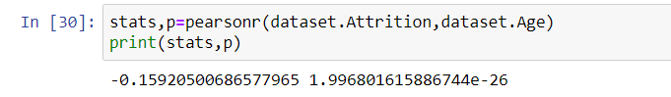

There low negative correlation between Age and Attrition. That means increase in attribute result into slight decrease in the value of another attribute.

* Correlation between Distance from home And Attrition :

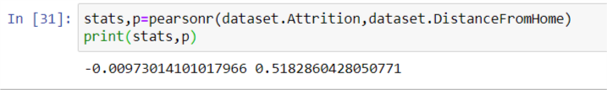

There low negative correlation between Distance from home and Attrition. That means increase in attribute result into slight decrease in the value of another attribute.

* 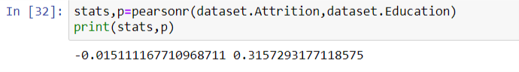Correlation between Education And Attrition :

There low negative correlation between Education and Attrition. That means increase in attribute result into slight decrease in the value of another attribute.

* Correlation between Monthly income And Attrition :

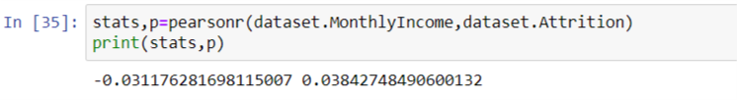

There low negative correlation between income and Attrition. That means increase in attribute result into slight decrease in the value of another attribute.

* Correlation between Training Times last Year And Attrition :

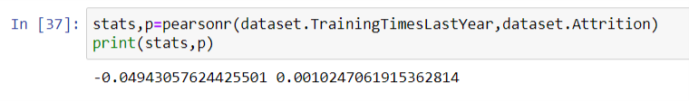

There low negative correlation between Training Times Last year and Attrition. That means increase in attribute result into slight decrease in the value of another attribute.

* Correlation between Years at Company And Attrition :

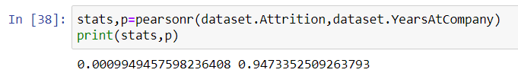

There low positive correlation between years at company and Attrition. That means increase in attribute result into slight increase in the value of another attribute.

* Correlation between percent salary hike And Attrition :

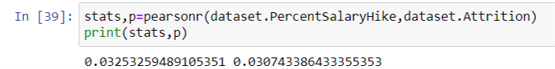

There low positive correlation between percent salary hike and Attrition. That means increase in attribute result into slight increase in the value of another attribute.

* Correlation between years with manager And Attrition :

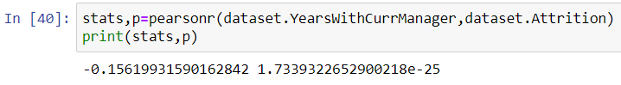

There low negative correlation between years with manager and Attrition. That means increase in attribute result into slight decrease in the value of another attribute.

* Correlation between Stock option level And Attrition :

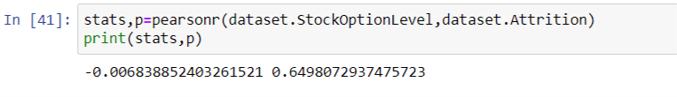

There low negative correlation between stock option level and Attrition. That means increase in attribute result into slight decrease in the value of another attribute.

* Correlation between years since last promotion And Attrition :

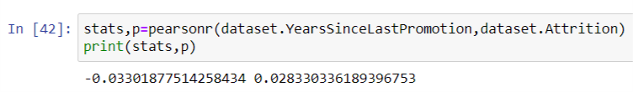

There low negative correlation between years since last promotion and Attrition. That means increase in attribute result into slight decrease in the value of another attribute.